# LAB ASSIGNMENT - 01 - PART – 2 – SPRING 2020

SIGNAL GENERATION

* Given a signal, we have to plot and display it.

Moreover, we have to change the time period of the waveform and define another signal for the same.

The given signal is,

1 + t ; -1 < t < 0

x(t) = 1 - t ; 0 < t < 1

0 ; otherwise

1. First, we have to plot x(t). By correctly constructing the code for the signal, we can easily develop the sketch of the signal x(t).

* 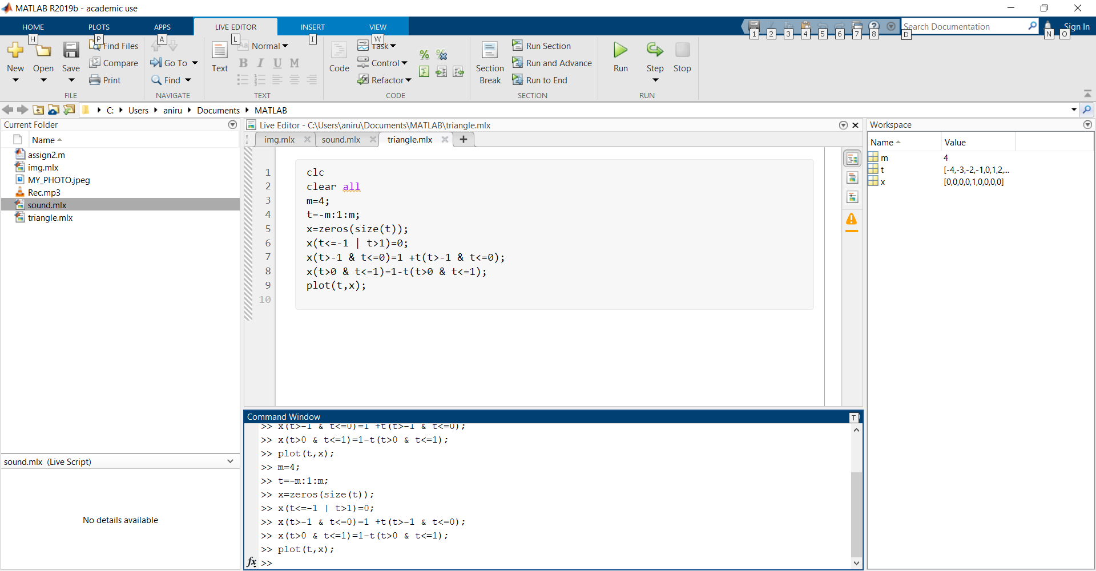Here is the code:

Here’s the output :

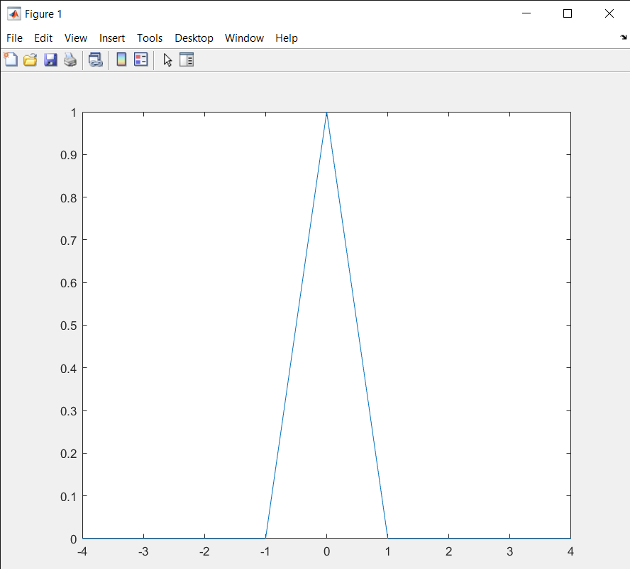

The other task assigned to create another signal y(t) which has a fundamental time period of 2.

* One method can be specifying the function for

each interval one by one and ultimately displaying

the signal. Like, in this way, we code the entire

signal x(t) having a fundamental period of 1 and

assuming the interval from [-5,5].

* Here’s the code…

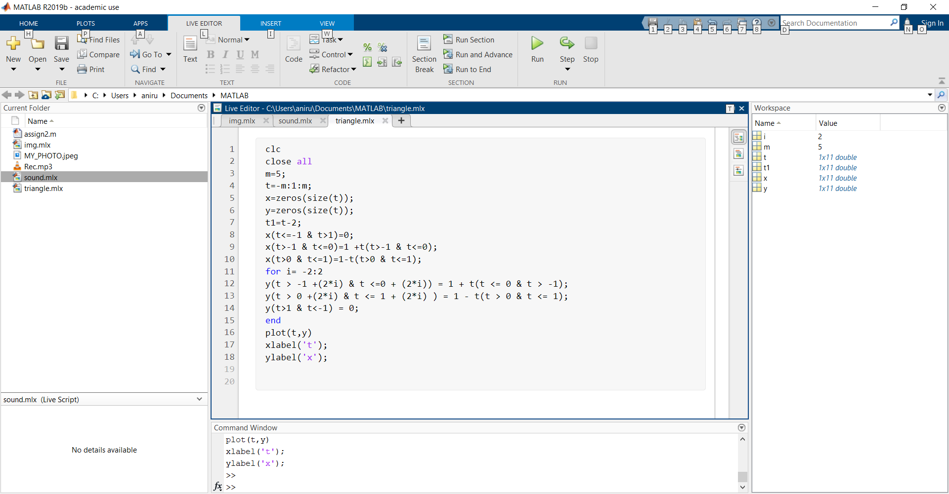

* Here’s the output …

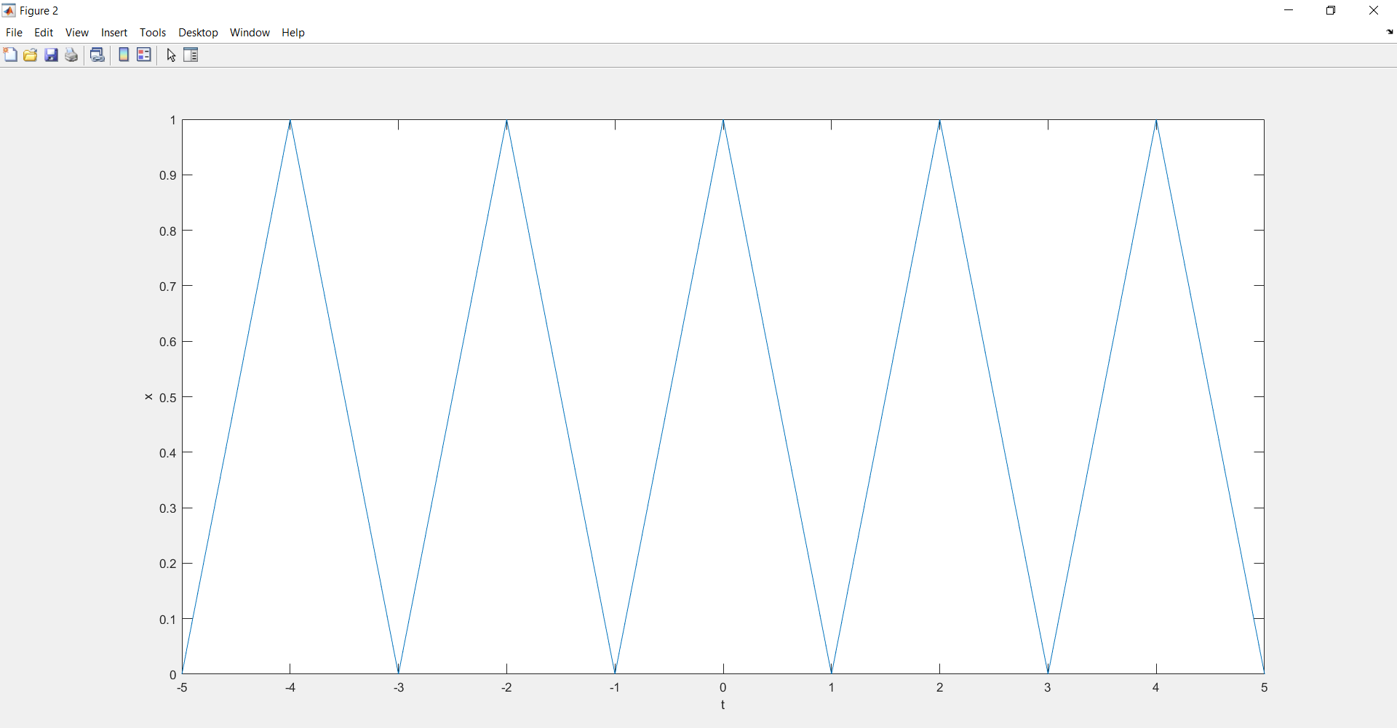

-----------------------THE END ----------------------------------